**Homework 3**

Department of Mechanical and Aerospace Engineering

University of California, San Diego

MAE 150

Lawrence Custodio

A08739279

31 January 2013

**Problem 2:**

**(a)**

Nominal value:

1.1796e+04

Worst Case Error:

301.4720

Statistical Error:

243.2613

Calculations were done through MATLAB as follows: results show that worse case error > statistical error

%Defining the variables:

rho = 8960; drho = 10; %density + uncertainty

D = 2e-6; dD = 0.01e-6; %diameter + uncertainty

L = 3e-4; dL = 0.03e-4; %length + uncertainty

E = 128.8e9; dE = 0; %Modulus + uncertainty

% Function + Partial derivativesnd

f = (0.56/L^2)*sqrt((E*D^2)/(16*rho));

frho = -(7*D^2*E)/(400*L^2*rho^2*((D^2*E)/(16*rho))^(1/2)); %df/drho

fD = (7*D*E)/(200*L^2*rho*((D^2*E)/(16*rho))^(1/2)); %df/dD

fL = -(28*((D^2*E)/(16*rho))^(1/2))/(25*L^3); %df/dL

fE = (7*D^2)/(400*L^2*rho*((D^2*E)/(16*rho))^(1/2)); %df/dE

disp('Nominal value:');

disp(f);

%Worst Case Error

fwce = abs(frho)*drho + abs(fD)*dD + abs(fL)*dL + abs(fE)*dE;

disp('Worst Case Error:')

disp(fwce)

%Statistical Error

fstat = sqrt(frho^2*drho^2 + fD^2*dD^2 + fL^2*dL^2 + fE^2*dE^2);

disp('Statistical Error:')

disp(fstat)

**(b) Uniform Distribution**



**Normal Distribution**



**(c)** Results suggests that the distribution of the independent variables *(L, E,)* will reflect on the distribution of the dependent variable (frequency). Uniform distribution for the dependent variable however, shows that there is a larger proportion of values along the mean versus the proportion of values at deviations ± from the nominal value.

**Problem 3: CAM Design**

**(a)**



**(b) Plot Pressure Angles**



**Table for pressure angle values:**

|  |  |  |  |  |  |  |  |  |  |  |  |  |  |
| --- | --- | --- | --- | --- | --- | --- | --- | --- | --- | --- | --- | --- | --- |
| **CAM angle [** | 0 | 30 | 60 | 90 | 120 | 150 | 180 | 210 | 240 | 270 | 300 | 330 | 360 |
| **Pressure Angle** [ | 0 | 50.812 | 55.631 | 41.781 | 8.394 | 0 | 0 | -20.337 | -25.658 | 0.055 | 0 | 0 | 0 |

**The range of pressure angle values suggest that the harmonic rise may not be designed optimally as the pressure angle reaches >30o, while the fall and the dwell ranges are consistent of the desired range of pressure angle value.**

**Problem 4: SolidWorks**

**Lesson 5: Assembly**

Wheelbarrow.sldasm

(Collapsed View)

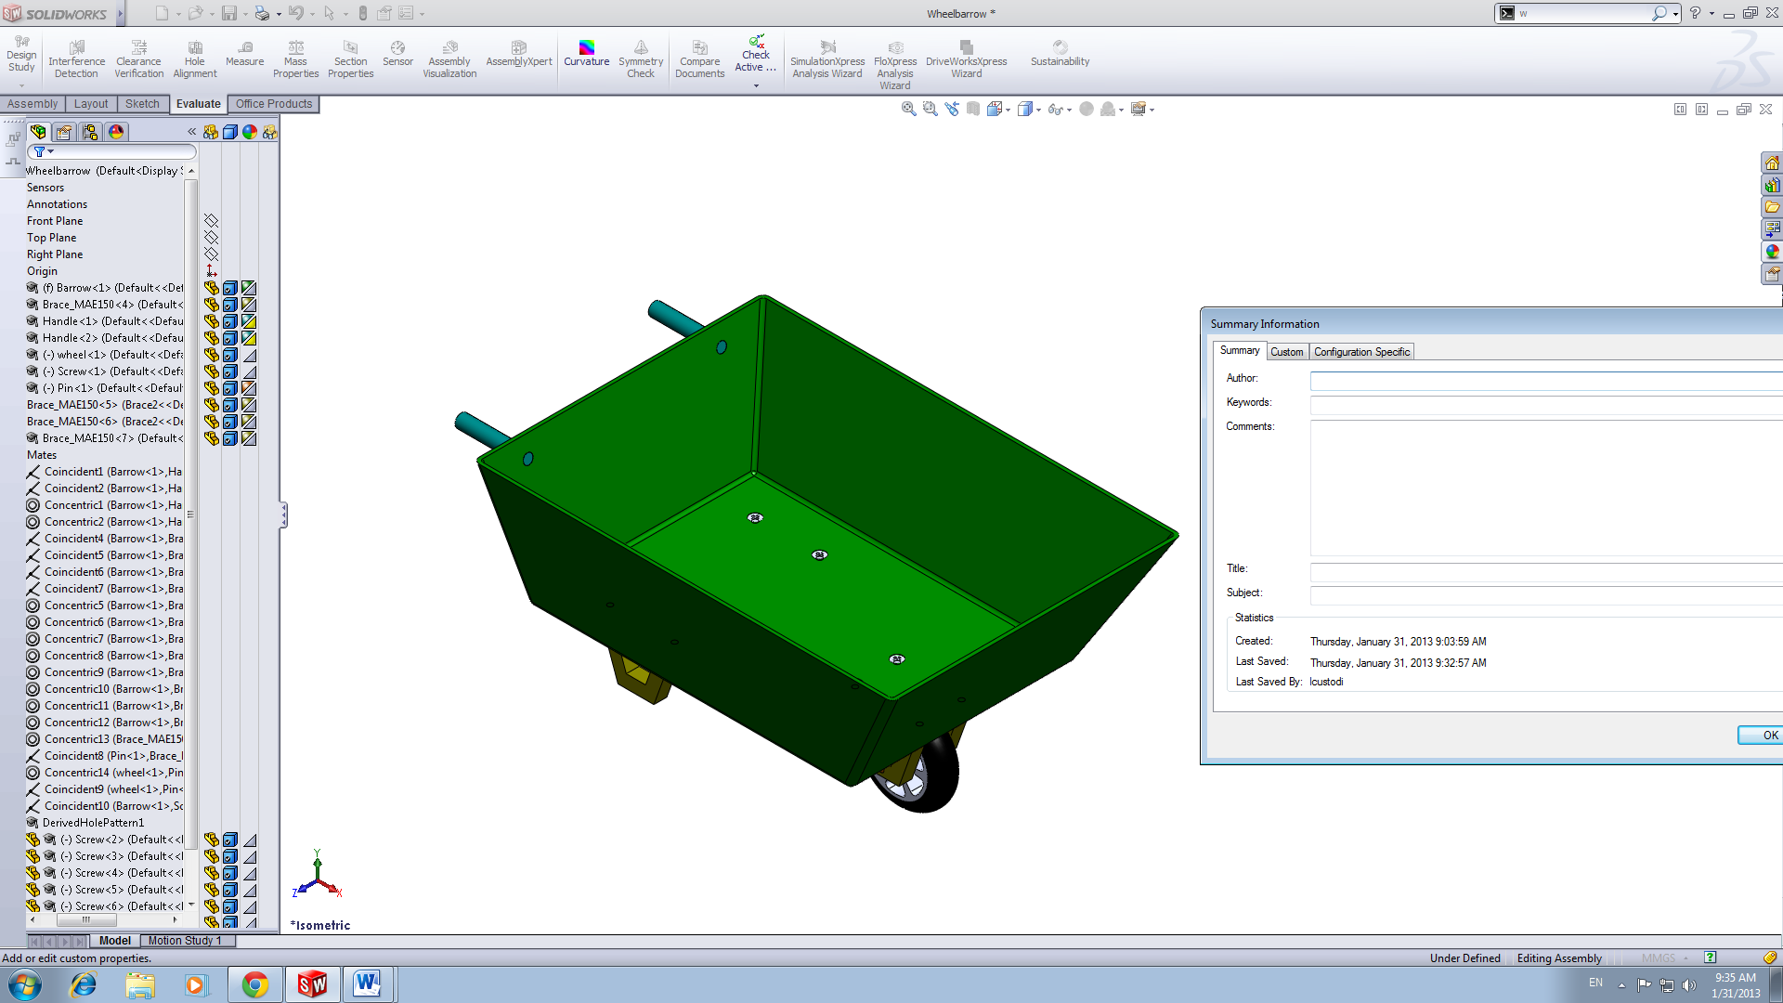

(Exploded View)

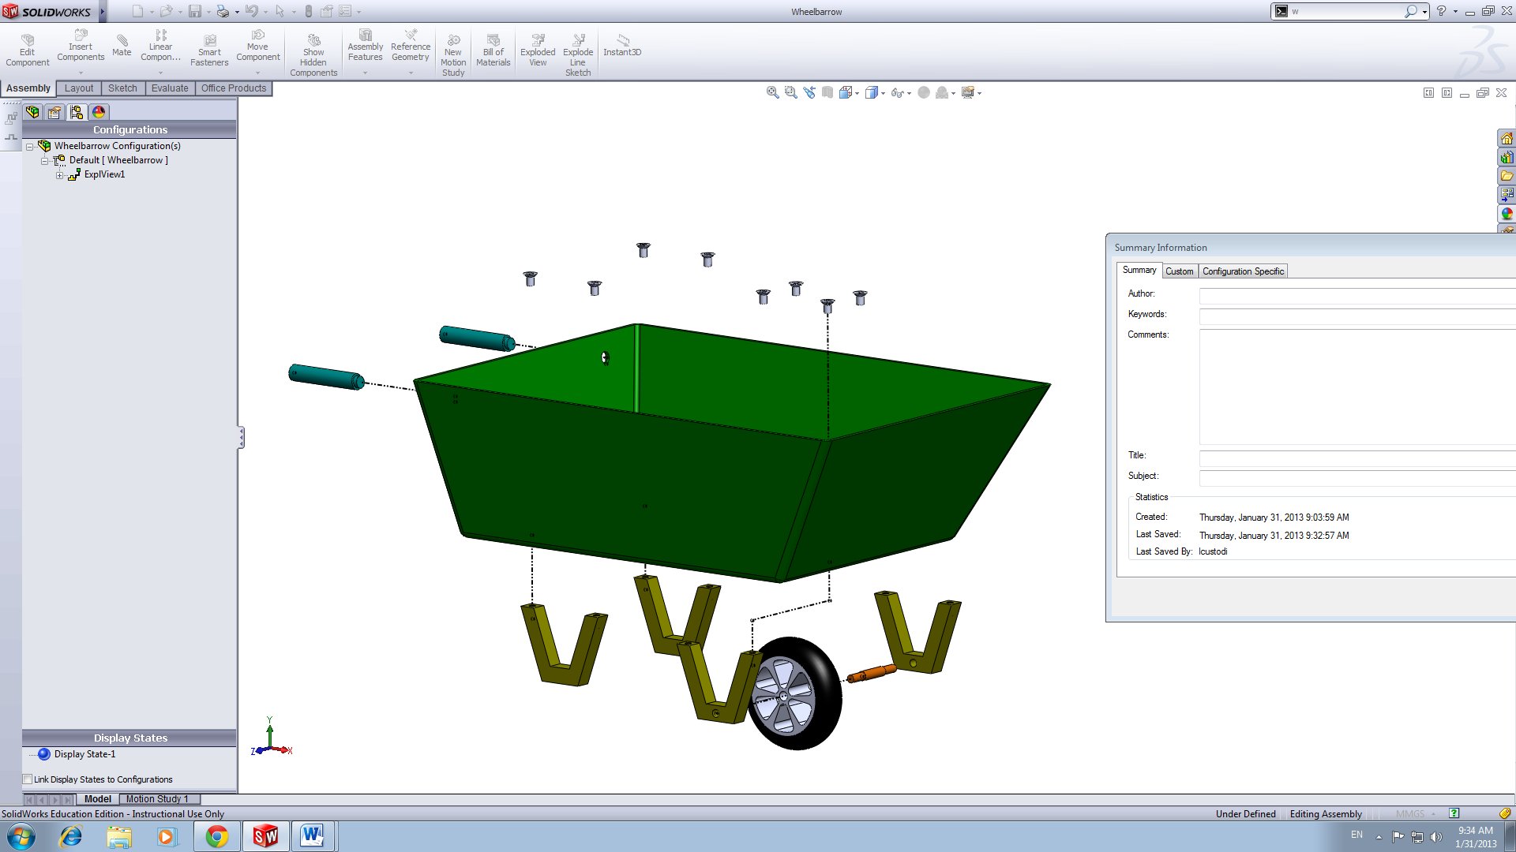

Lesson 6: Finite Element Analysis

Displacement Figure

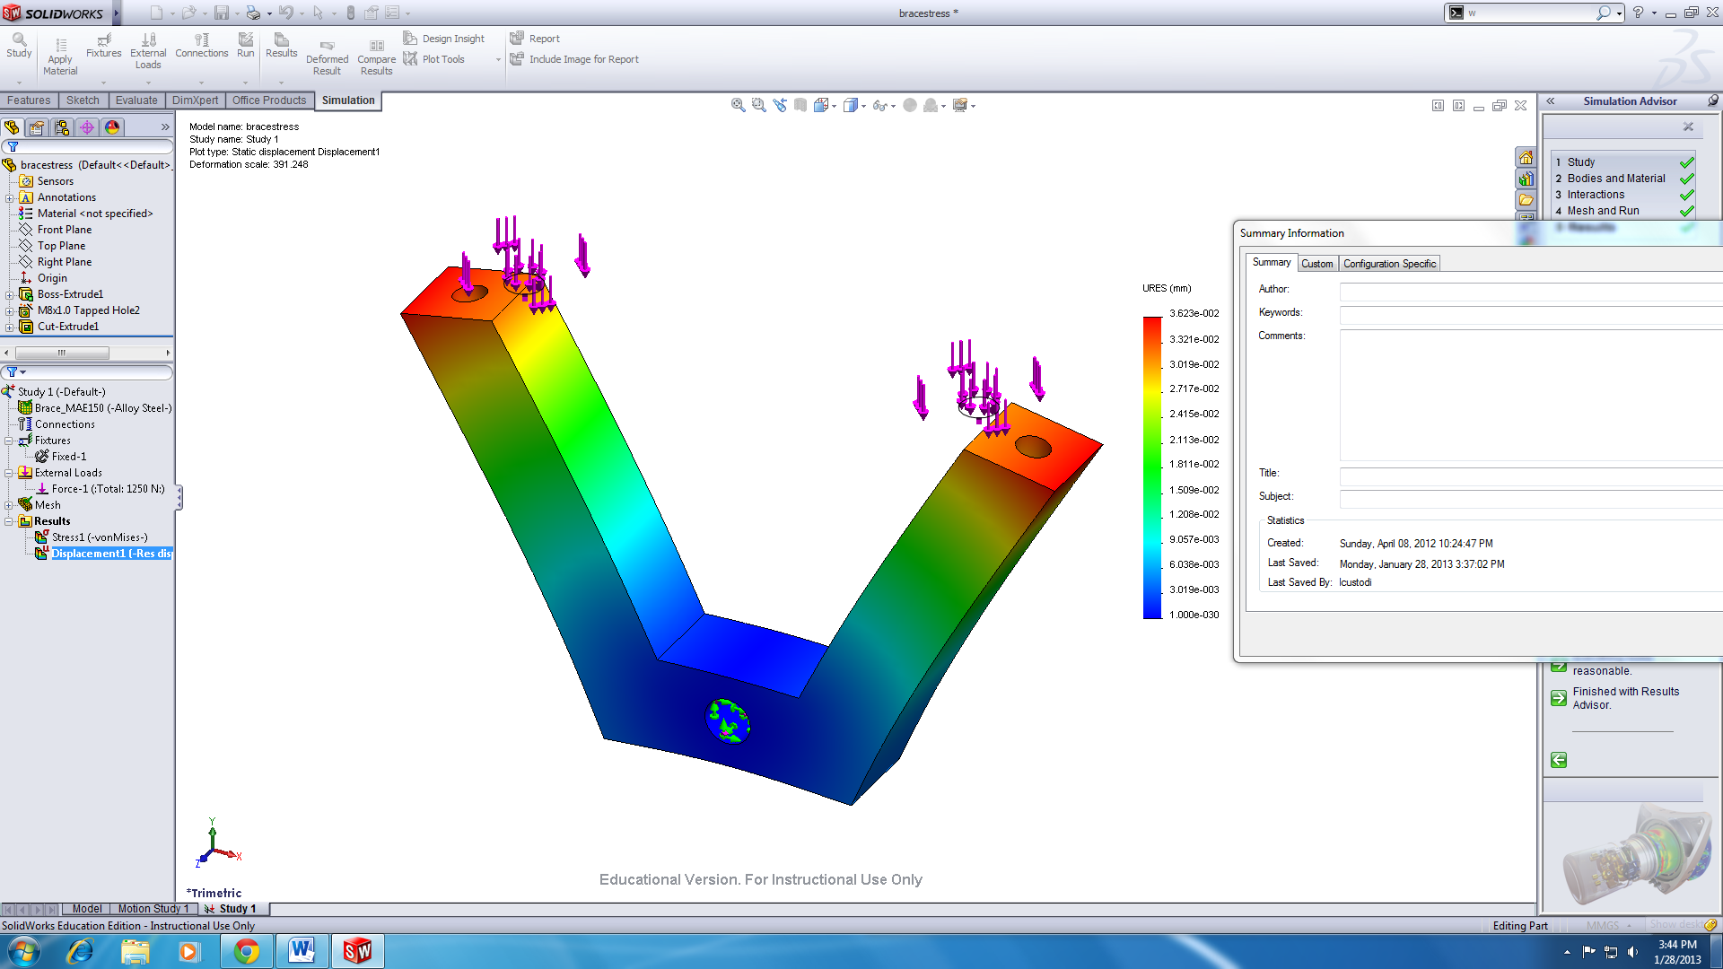

Stress figure of vonMises stress

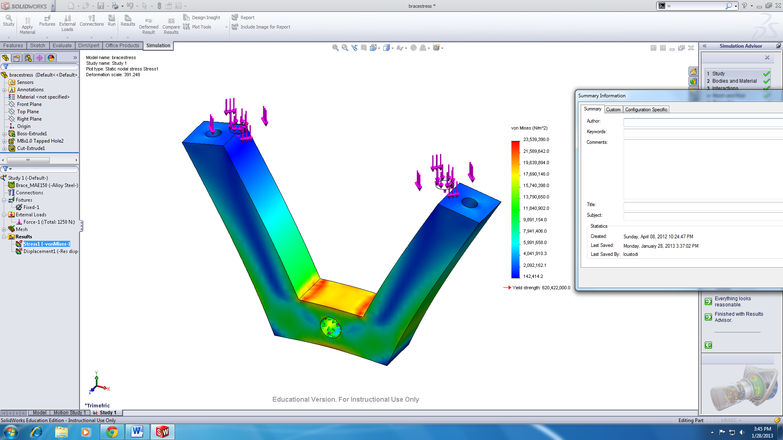

Stress Iso-Clipping

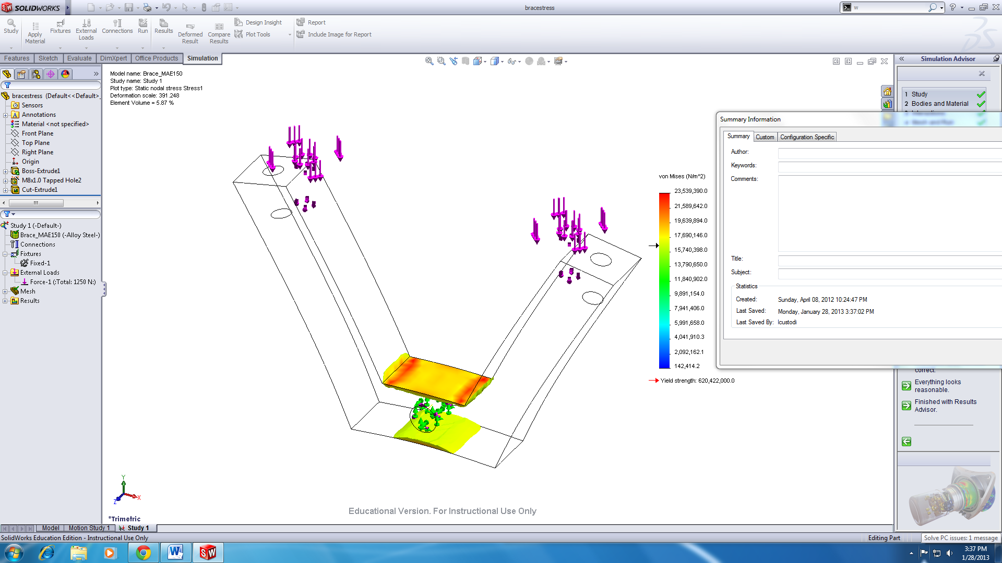

**Appendix: MATLAB Code**

**Problem 2:**

clear;clc;

%Part A

%Defining the variables:

rho = 8960; drho = 10; %density + uncertainty

D = 2e-6; dD = 0.01e-6; %diameter + uncertainty

L = 3e-4; dL = 0.03e-4; %length + uncertainty

E = 128.8e9; dE = 0; %Modulus + uncertainty

% Function + Partial derivativesnd

f = (0.56/L^2)*sqrt((E*D^2)/(16*rho));

frho = -(7*D^2*E)/(400*L^2*rho^2*((D^2*E)/(16*rho))^(1/2)); %df/drho

fD = (7*D*E)/(200*L^2*rho*((D^2*E)/(16*rho))^(1/2)); %df/dD

fL = -(28*((D^2*E)/(16*rho))^(1/2))/(25*L^3); %df/dL

fE = (7*D^2)/(400*L^2*rho*((D^2*E)/(16*rho))^(1/2)); %df/dE

disp('Nominal value:');

disp(f);

%Worst Case Error

fwce = abs(frho)*drho + abs(fD)*dD + abs(fL)*dL + abs(fE)*dE;

disp('Worst Case Error:')

disp(fwce)

%Statistical Error

fstat = sqrt(frho^2*drho^2 + fD^2*dD^2 + fL^2*dL^2 + fE^2*dE^2);

disp('Statistical Error:')

disp(fstat)

%Part B:

%Uniform Distribution + Plotting

n = 1e4 ; %r sample-size

figure;

%Independent Variable Distribution: diameter

r2 = rand(n,1);

ud = 2*dD*r2+(D-dD);

subplot(222)

hist(ud,50);

xlabel('[m]')

title('Diameter')

%Independent Variable Distribution: length

r3 = rand(n,1);

ul = 2*dL*r3+(L-dL);

subplot(223)

hist(ul,50);

title('Length')

xlabel('[m]')

%Independent Variable Distribution: density

r4 = rand(n,1);

urho = 2*drho*r4+(rho-drho);

subplot(224)

hist(urho,50);

title('Density')

xlabel('[kg/m^3]')

%Dependent Variable Distribution: frequency

ufreq = (0.56*ul.^-2).*sqrt((E*ud.^2)./(16*urho));

subplot(221)

hist(ufreq,50);

title('Frequency')

xlabel('[Hz]')

%Normal distribution

figure;

%Diameter

r2n = sqrt(2)*erfinv(2*r2-1); %Normally distributed random number array

nD = D + (dD/3)*r2n; %Normal dist. formula

subplot(222)

hist(nD,50);

title('Diameter')

xlabel('[m]')

%Length

r3n = sqrt(2)*erfinv(2*r3-1); %Normally distributed random number array

nL = L + (dL/3)*r3n; %Normal dist. formula

subplot(223)

hist(nL,50);

title('Length')

xlabel('[m]')

%Density

r4n = sqrt(2)*erfinv(2*r4-1); %Normally distributed random number array

nrho = rho + (drho/3)*r4n; %Normal dist. formula

subplot(224)

hist(nrho,50);

title('Density')

xlabel('[kg/m^3]')

%Dependent variable: Frequency

nfreq = (0.56*nL.^-2).*sqrt((E*nD.^2)./(16*nrho));

subplot(221)

hist(nfreq,50);

title('Frequency')

xlabel('[Hz]')

**Problem 3:**

%CAM Design

clc; clear; close all;

L =20; %Given length of rise +fall

w = 600; %rotational speed

%Harmonic Rise

t1 = (0:120)*pi/180; %Range of Harmonic Rise (rad)

b1 = t1(end)-t1(1); %Beta value

y1 = (L/2)*(1-cos((pi*t1)/b1)); %Displacement

y1dt = (0.5*pi*L*w*b1)*sin((pi*t1)/b1);%Velocity

y1dt2 = (L/2)*((pi*w/b1)^2)*cos(pi*t1/b1); %Acceleration

%Dwell

t2 = (120:180)*pi/180; %Range of Dwell (rad)

y2 = 20*ones(1,length(t2)); %Horizontal line describing dwell

y2dt = zeros(1,length(t2)); %Zero velocity for dwell

y2dt2 = zeros(1,length(t2));

%345 Poly Fall

t3 = (0:90)*pi/180; %Range of fall (rad)

b3 = t3(end)-t3(1); %Beta for poly 345 fall

y3 = L-L*(10*(t3/b3).^3 - 15*(t3/b3).^4 + 6*(t3/b3).^5); %Displacement

y3dt = L-L*((30*w/b3^3)*t3.^2 - (60*w/b3^4)*t3.^3 + (30*w/b3^5)*t3.^4 ); %Velocity

y3dt2 = L-L*((60*w^2/b3^3)*t3 - (180*w^2/b3^4)*t3.^2 + (120*w^2/b3^5)*t3.^3); %Acceleration

%Dwell

t4 = (270:360)*pi/180;

y4 = zeros(1,length(t4));

y4dt = zeros(1,length(t4)); %Zero velocity for dwell

y4dt2 = zeros(1,length(t4));

%Graphing:

%Respective ranges for angles are converted in degrees:

tt = 0:120; %Harmonic Rise

tt2 = 120:180; %Dwell

tt3 = 180:270; %345 Poly Fall

tt4 = 270:360; %Dwell

t = [tt tt2 tt3 tt4]; %Angles

disp = [y1 y2 y3 y4]; %Displacement values

vel = [y1dt y2dt y3dt y4dt]; %Velocity

acc = [y1dt2 y2dt2 y3dt2 y4dt2]; %Acceleration

subplot(311)

plot(t,disp)

title('Displacement Profile ')

ylabel('Displacement[mm]')

xlim([0 360]);

ylim([0 30]);

subplot(312)

plot(t,vel)

title('Velocity Profile')

ylabel('Velocity [mm/s]')

xlim([0 360]);

subplot(313)

plot(t,acc)

title('Acceleration Profile')

xlabel('Cam angle [\theta]')

ylabel('Acceleration[mm/s^2]')

xlim([0 360]);

%Part B: Pressure angle

phi = atan((vel./w)./(35+disp)); %Pressure angle formula

phid = phi*180/pi; %Pressure angle values to degrees

figure

plot(t,phid)

title('CAM Pressure angle')

xlabel('CAM Angle [\theta]')

ylabel('Pressure Angle \phi[deg]')

%Table values for every 30 deg:

x = [t(1) t(31) t(61) t(91) t(121) t(152) t(182) t(213) t(243) t(273) t(304) t(334) t(364)]; % Selected angle values

pa = [phid(1) phid(31) phid(61) phid(91) phid(121) phid(152) phid(182) phid(213) phid(243) phid(273) phid(304) phid(334) phid(364)]; %Pressure angle values

table=[x;pa]

**I verify that the above homework was generated by me alone, without the help of any other person**

**Signature / Date**